**Team ID: PNT2022TMID23510**

**SMART FARMERS –** **IOT ENABLED SMART FARMING APPLICATION**

**IBM WATSON IOT PLATFORM AND A DEVICE**

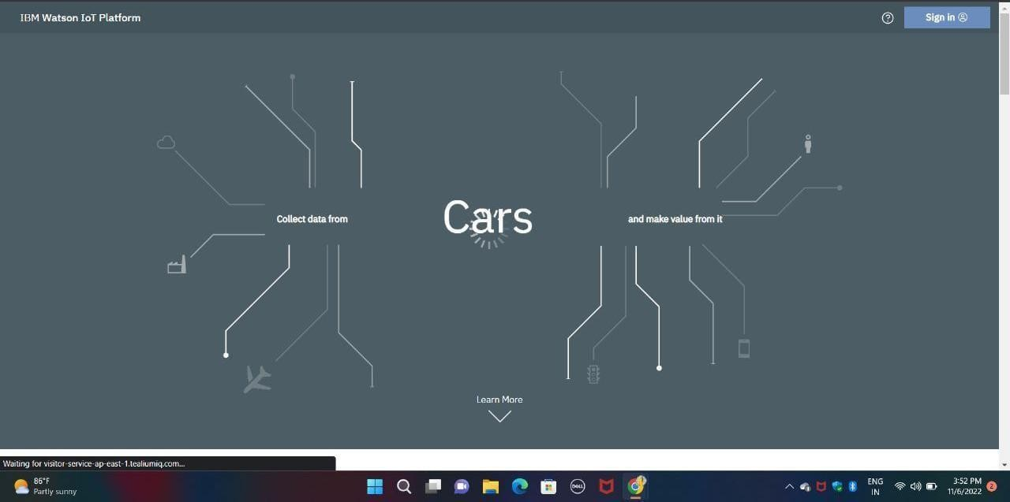Step 1:

Step 2

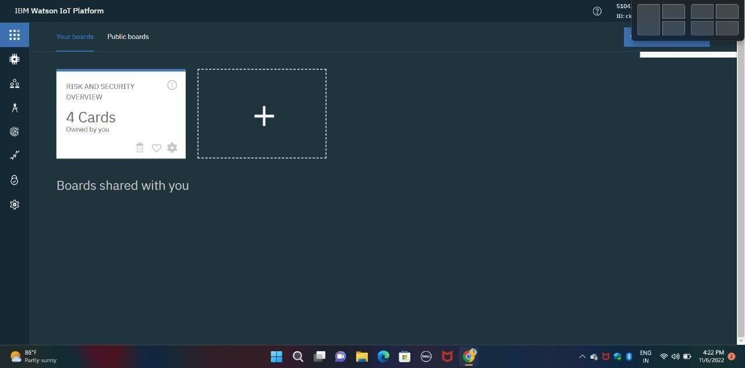

Step 3:

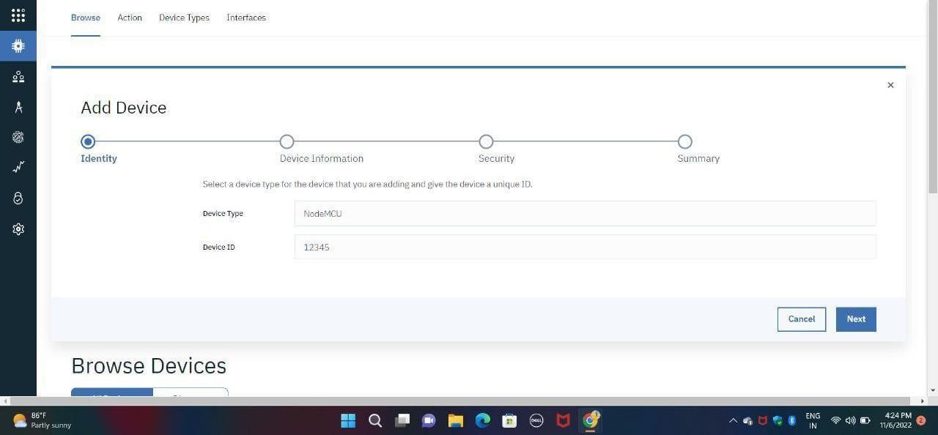

Step 4:

Step 5:

